**Introduction**

The main aim of our project is to provide a platform to search for short term jobs for U6 category labor workforce of USA. This platform provides the opportunity to job seekers who are looking for part time jobs to meet their financial requirements. On the other hand it is helpful to find for the people who need help in completing their activities like Tutoring, Store Management, Party coordination, pickup or drop rides and other household activities etc.

**Motivation and Goal**

According to United States Department of Labor Statistics, Labor workforce of USA is categorized as U1, U2, U3, U4, U5, and U6. U6 category labor workforce is a combination of U1 to U5 categories. In simple terms citizens who are not having full time employment are categorized under U6 labor workforce. Fig 1 gives us the graphical information of Unemployed U6 workforce from 2000 to 2014. Post-recession US economy improved significantly which reduces the U6 unemployed workforce from almost 17.1% to 11.2% by Dec 2014 statistics.

At present the labor force participation rate is fallen to 62.7% which is the lowest rate since 1978 as shown in fig 2. LFPR is the ratio of the labor force and overall size of labor force of the same age range. Lowest LFPR is not good for US Economy. Online job portal are significantly helpful in improving the labor force participation rate.

**How to use the system**

* Our system serves as a bridge between the employers and jobseekers.
* A user can able to sign up into our mobile application as a new user and sign in to our application. User can also able to sign in using **Google+** or **LinkedIn**.
* An employer can able to post a new job and retrieve the already posted jobs.
* An employer can edit a job which was posted previously. He can also accept or reject the applications based on the test score of the applicant.
* Employer can able to send a mail directly to the applicants whom he accepted for a particular job.
* An applicant can search for a particular job. The corresponding jobs will be listed based on his search criteria.
* An applicant can apply for a job of his interest. He has to complete a series of questions related to the applied job. This will give an understanding to the employer regarding the applicant’s skills towards the job he had applied for.

**Error recognition and handling**

Our project is clean in implementation. As of now we don’t have any standing errors in our working code.

**Sample interaction example**

Applicant tasks include search for job/apply for job/view status of the applied job.

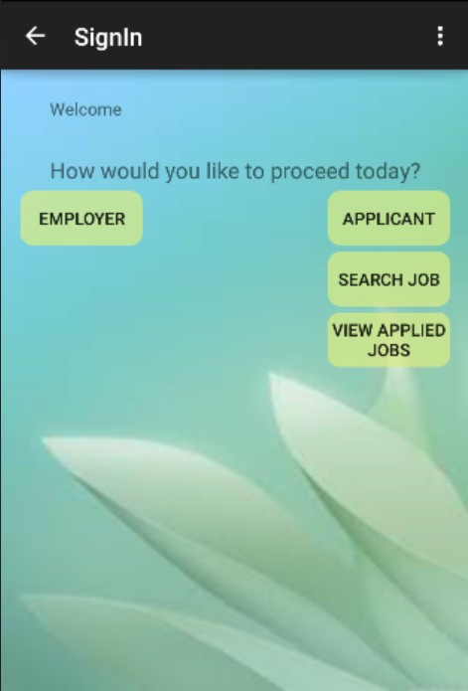 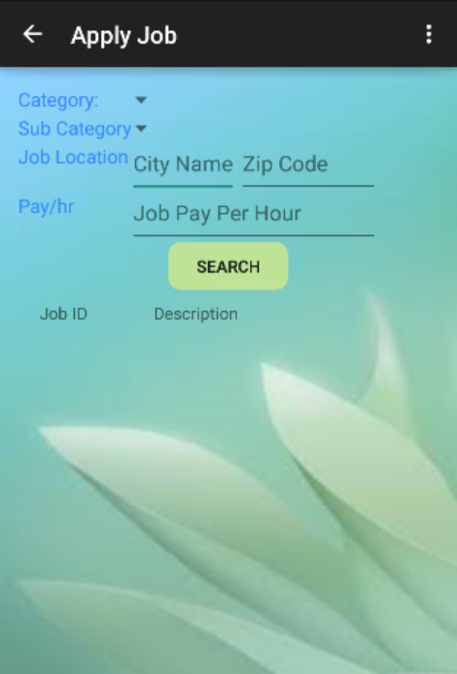

The below screens show that the Applicant can search for a job and based on the search criteria the list of available jobs is shown to the applicant from which the applicant can select any job and Apply for the job.

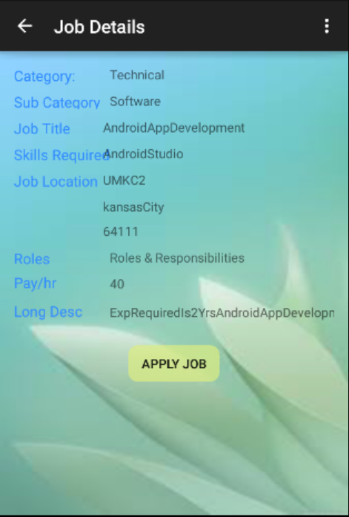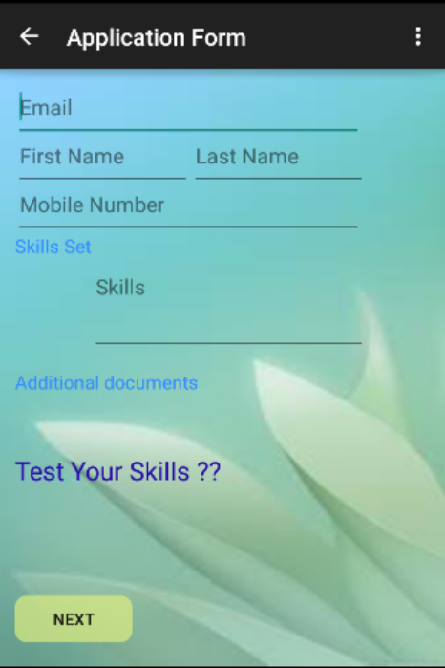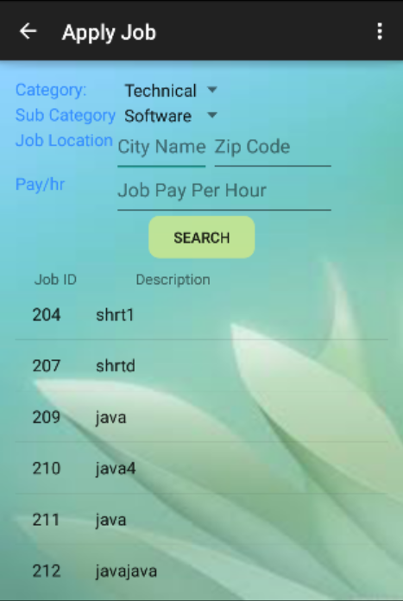

The below screen asks the applicant to fill the details and take test

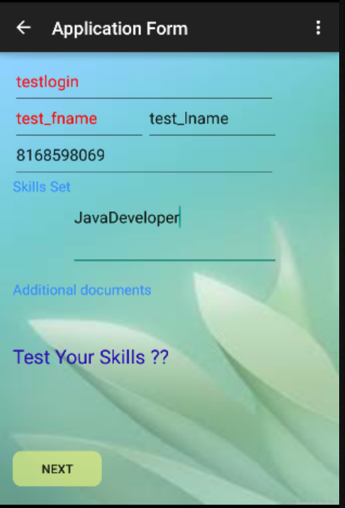

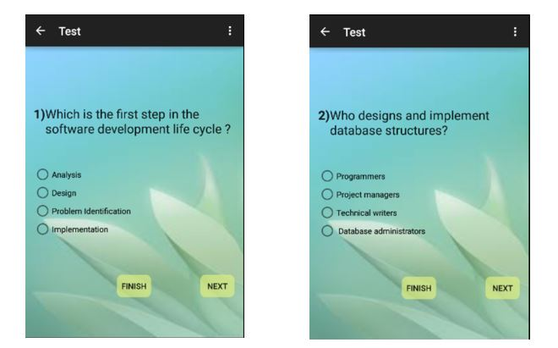The below screen shows that the Applicant can take test and the score will be updated in the database so that the employer can select the applicant based on the test score.

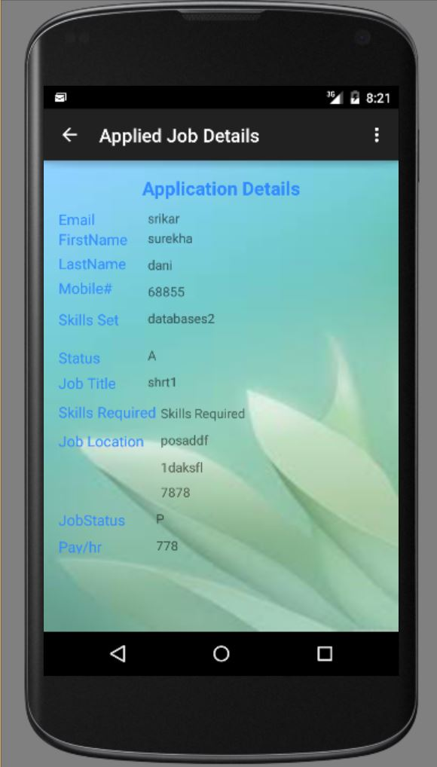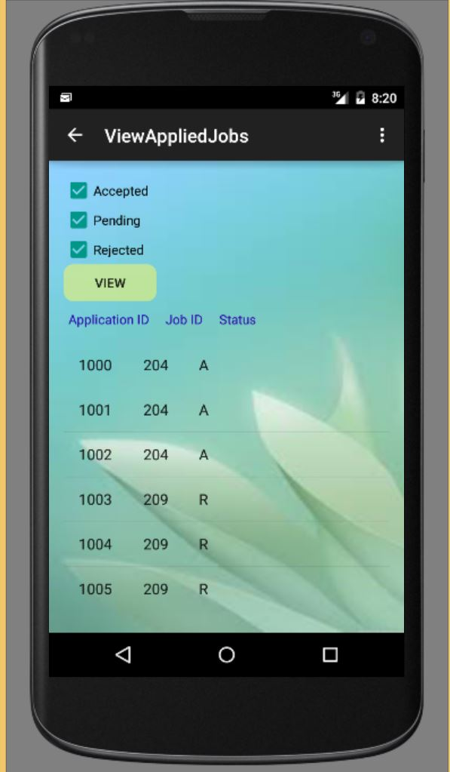The Below Screens allows the Applicant to view all the Applied Jobs and on clicking on the Application ID we can fetch all the details of job application.

**List of known bugs and deficiencies**

* We would like to improve on providing different search criteria for the applicant in order to improve his search experience and generate even more concise and detailed results.
* Improve the validation prospects of the applicant who is applying for non-technical jobs.